**PF LAB #4 TASK**

**Name :** Muhammad Jawwad

**Section & Roll No. :** BCS 1K-0536

Task 1: Check Voting Eligibility

CODE:

#include <stdio.h>

int main()

{

int age;

printf("Enter your Current Age Number\n");

scanf("%d", &age);

if (age<=18)

{

printf("Not Eligible to Vote\n");

}

else {

printf("Is Eligible to Vote\n");

}

return 0;

}

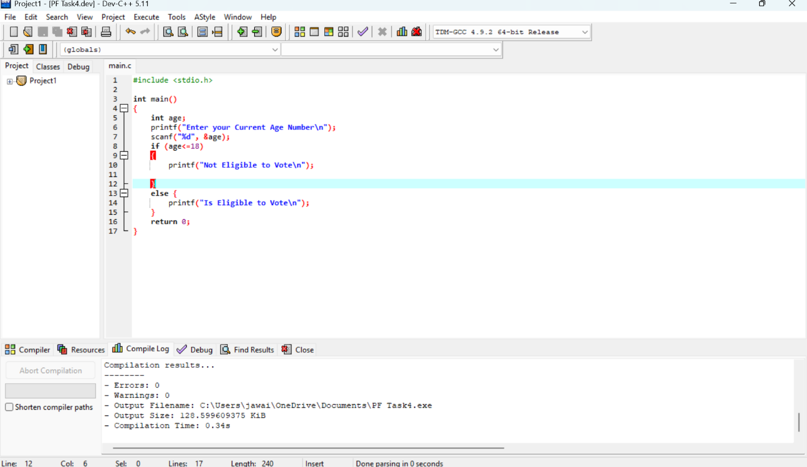

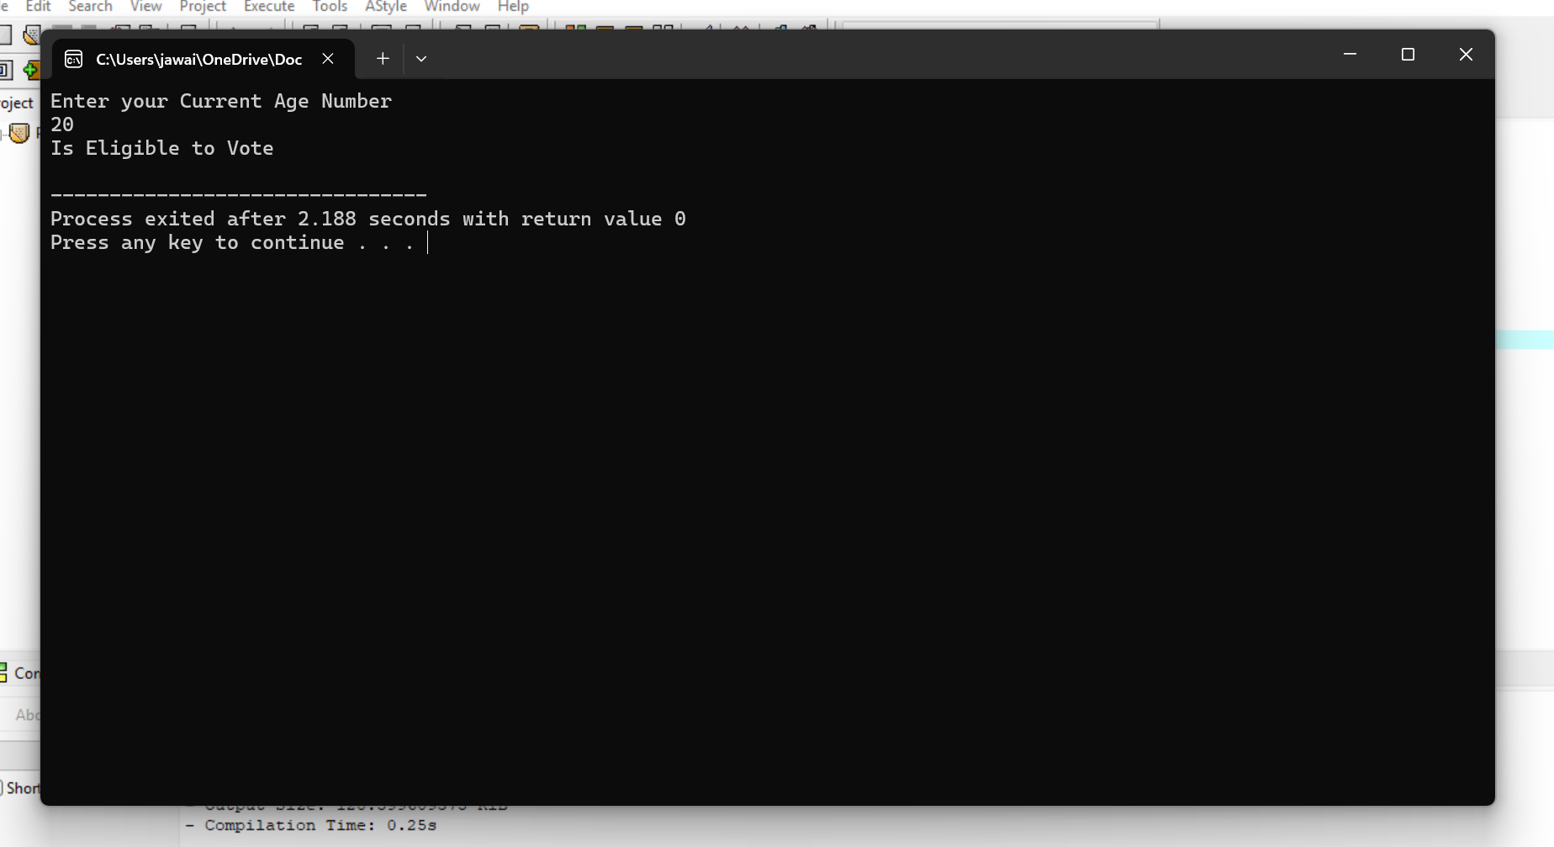

Task 2: Odd or Even Number

CODE:

#include <stdio.h>

int main()

{

int Value;

printf("Enter a Number: \n");

scanf("%d", &Value);

if(Value%2==0)

{

printf("The Given Number is Even : \n");

}

else{

printf("The Given Number is Odd : \n");

}

return 0;

}

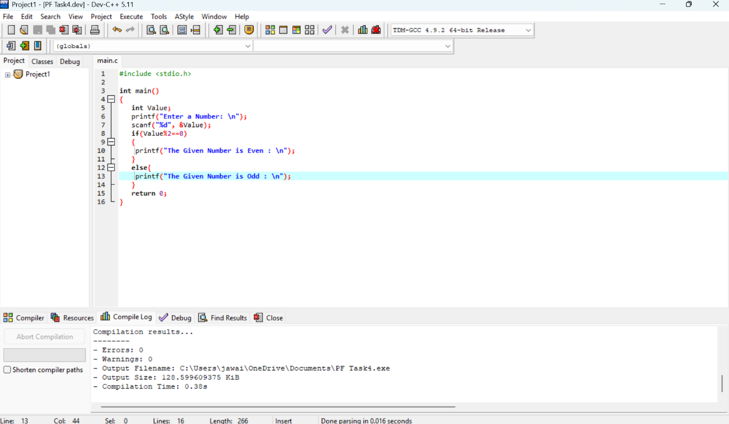

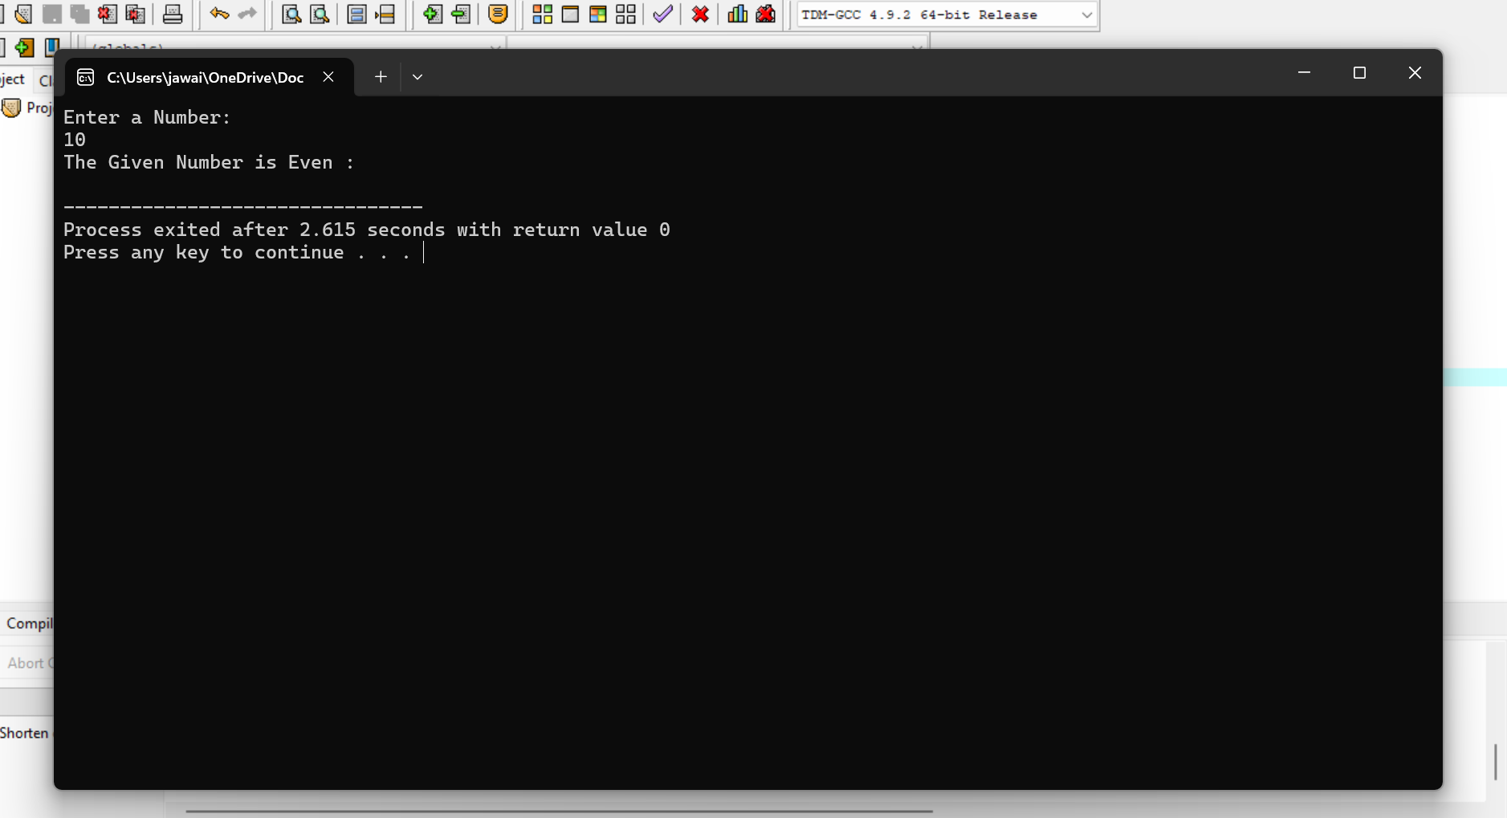

Task 3: Find Largest Among Three Numbers

CODE:

#include <stdio.h>

int main()

{

int num1 , num2 , num3 ;

printf("Enter First Number : \n");

scanf("%d", &num1 );

printf("Enter Second Number : \n");

scanf("%d", &num2 );

printf("Enter Third Number : \n");

scanf("%d", &num3 );

if(num1 >= num2 && num1 >= num3 ){

printf("Largest Number is : %d\n", num1);}

else if (num2 >= num1 && num2 >= num3 )

{

printf("Largest Number is : %d\n", num2);}

else{

printf("Largest Number is : %d\n", num3);

}

return 0;

}

